**Chapter 3: Requirements and Analysis**

**3.1 Problem Definition:**

The project aims to solve problems in traditional library systems where manual processes often lead to errors, slow book transactions, and difficulties in keeping track of members and books. Users have trouble accessing the library's book lists and managing their accounts online, and administrators struggle to organize book details, author and publisher information, and make sure books are returned on time. The Online Library Management System requires the ability for new users to sign up and create accounts, as well as for existing members to securely log in and access their personal profiles where they can view and track the books they have borrowed. The system must provide a comprehensive and easily accessible catalog of all available books, allowing any user to browse through titles along with their associated authors and publishers. For administrators, the system should offer a secure login that grants access to management functions such as adding, updating, or deleting details about authors, publishers, and books in the inventory. It must also facilitate the efficient issuing and returning of books, keeping accurate records of transactions and monitoring due dates to ensure timely returns. Additionally, administrators should have the capability to manage user information effectively, including updating profiles and changing user statuses when necessary. Overall, the system should be designed to be user-friendly and accessible from any device with internet access, ensuring smooth and efficient operations for both library members and administrators.

The **Requirements Specification** for the Online Library Management System defines the key elements and actions within the system. Users can sign up, log in, and manage their profiles, including viewing their borrowed books. They can also browse the entire book collection. Administrators have additional capabilities, such as managing books, authors, and publishers by adding, updating, or deleting records. They are responsible for issuing and returning books, updating the inventory, and tracking due dates. Administrators also manage user accounts and have secure access to all system functions. This specification outlines what the system must do without detailing how it will be implemented.

**3.2 Planning and Scheduling:**

**3.2.1 Planning**

Planning for the Online Library Management System involves a thorough process to ensure the project is completed efficiently and on time. The first step is to break down the project into smaller, manageable tasks. This includes designing the user interface to make it user-friendly, setting up the database to store all book and user information, coding the backend to handle the system’s functionalities, and performing comprehensive testing to ensure everything works correctly. Each task must be clearly defined to cover all aspects of the project. For example, designing the user interface involves creating layouts and ensuring usability, while setting up the database requires defining tables and relationships for storing data. Coding the backend includes implementing features such as book issuing and user management, and testing ensures that all parts of the system function together smoothly. Constraints and rules that could impact the scheduling of tasks must be recognized. For instance, the backend coding cannot start until the database setup is completed because the database is needed to store and retrieve data. Other constraints may include the availability of resources, such as software tools or hardware, and deadlines that must be met. **Plan A** outlines the ideal approach for completing the project, detailing the best sequence for each task and setting a timeline for when each task should be finished. This plan helps in organizing the work and keeping track of progress. **Plan B** provides a backup strategy to handle potential problems, such as delays or unexpected issues. It includes alternative solutions to address any challenges that might arise, ensuring that the project stays on track despite any obstacles. Effective planning is crucial for completing the project as scheduled. It involves not only defining tasks and setting timelines but also preparing for any issues that could disrupt progress. By having clear plans and strategies in place, the project remains organized, and the likelihood of successful and timely completion is increased.

**3.2.2 Scheduling**

**Gantt Chart**

The Gantt chart outlines a project with four distinct phases labeled as Chapters 1 through 4. The project is scheduled to commence on July 13th and conclude on September 11th. Chapter 1 is the initial phase, spanning from July 13th to July 23rd. Following this, Chapter 2 commences on August 2nd and concludes on August 12th. Chapter 3 is positioned after Chapter 2, starting on August 22nd and finishing on September 1st. The final phase, Chapter 4, is the longest, extending from September 1st to September 11th. The chart visually represents the project's timeline, clearly indicating the start and end dates for each chapter, allowing for easy understanding of the project's duration and sequence.

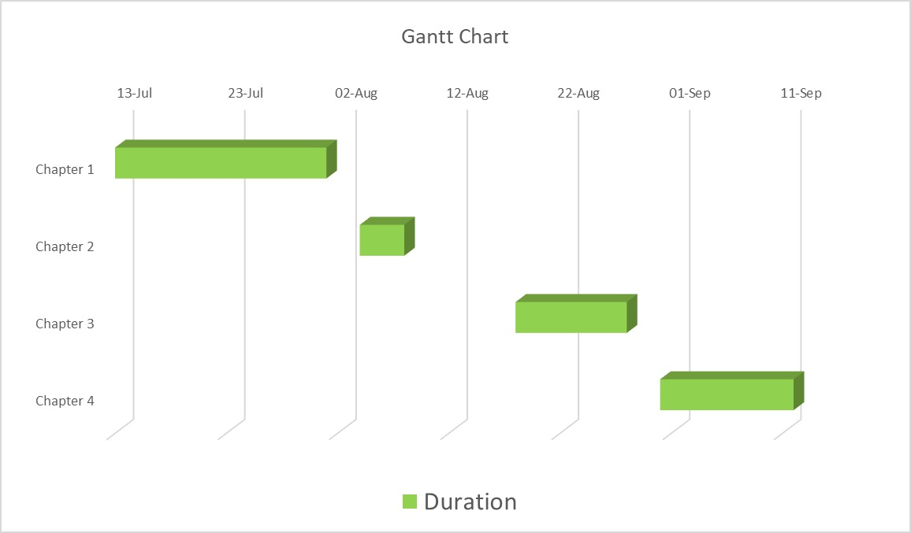

**Figure 3.1: Gantt Chart**

**PERT Chart**

A PERT chart is a visual project management tool that’s useful for mapping out project tasks and planning the overall project schedule. Many people confuse PERT with PERT chart, so the best way to provide a comprehensive PERT chart definition is to start with clarifying both of these terms. PERT stands for Program Evaluation Review Technique. PERT is the actual technique that is used to create a PERT chart. Meanwhile, a PERT chart is the visual diagram that results from using PERT. Think of PERT asthe process and the PERT chart asthe outcome. PERT charts allow project managers to see essentialscheduling details such astask dependencies, task duration estimates, and the minimum amount of time a project can be completed within. But, they’re not the most user-friendly or wellunderstood tool.

The below PERT diagram shows the schedule of the following chapters.

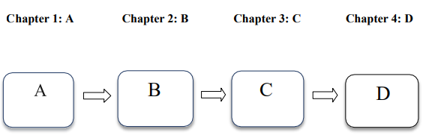

**Figure 3.2: Activity**

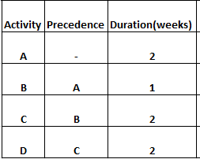

**Table 3.3: Critical Activity**

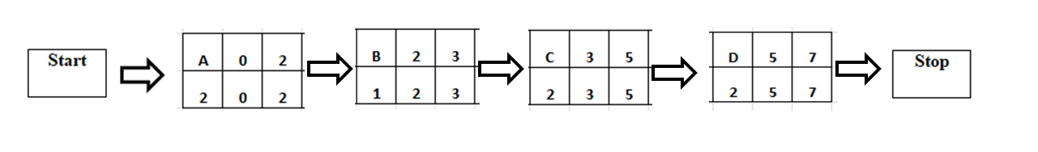

**Figure 3.3: Critical Activity**

Slack = 0 for all the activities.

Therefore, Critical Path = A-B-C-D .

**3.3 Hardware and Software Requirement:**

**3.3.1 Hardware Requirement**

The hardware and software requirements for the Online Library Management System are essential for ensuring optimal performance and reliability. **Hardware requirements** include a dedicated or cloud-based server with a minimum 2 GHz dual-core processor, 4 GB of RAM, and 50 GB of storage to manage the database and application files. The server should also have a reliable internet connection with adequate bandwidth. Client machines, such as desktops or laptops, should be equipped with at least a 1.8 GHz dual-core processor, 4 GB of RAM, and 10 GB of free storage space. Additionally, a backup device, such as an external hard drive or cloud storage service, is needed for regular backups of the database and application files.

**3.3.2 Software Requirement**

**Software requirements,** the frontend of the application will be developed using ASP.NET and Bootstrap to create a responsive and user-friendly interface. The backend will utilize C# for the application logic and functionality. The database management will be handled by MySQL, which will store and manage user and book data. Development tools include an Integrated Development Environment (IDE) like Visual Studio for ASP.NET and C# development, and MySQL Workbench for managing the MySQL database. The application will be hosted on a web server compatible with ASP.NET, such as Internet Information Services (IIS). The server will run on Windows Server or a compatible Linux distribution, while client machines can use Windows, macOS, or a compatible Linux distribution. Users will access the application through modern web browsers such as Google Chrome, Mozilla Firefox, or Microsoft Edge. These specifications ensure the system operates smoothly and meets all functional requirements.